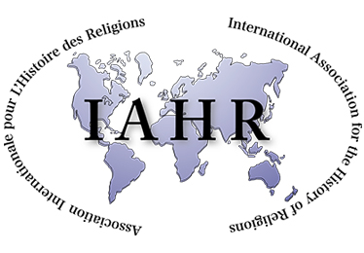

Call For Papers

BASR Annual Conference 6-8 September 2021, School of Divinity, University of Edinburgh

“From Religious Studies to the Study of Religion/s: Disciplinary Futures for the 21st century”

We warmly invite contributions to the BASR annual conference 2021. The 2021 conference falls in the 175th anniversary year of the foundation of New College, home of the School of Divinity, and marks the 50th anniversary of the teaching of Religious Studies at Edinburgh. The conference is also designated a IAHR Special Conference and we look forward to welcoming international colleagues.

The aim of the conference is to discuss disciplinary and interdisciplinary pasts and futures in Religious Studies or the Study of Religion/s, with a particular focus on the future shape of the field in the 21st Century. After a period of sharp critique of many of the field’s basic categories and axioms, it feels timely now to reflect upon what the field has positively achieved, the challenges it has faced (and overcome), and the direction(s) it should now pursue.

The scope of the conference is the post-1960s period up to and including the present moment, during which Religious Studies emerged, consolidated and diversified as a recognised disciplinary field or ‘brand’. Local and regional histories of the field during this period are welcome, particularly where they identify problems or strengths for the future, or can illuminate regional or international developments. We are particularly interested in exploring the grounds for positive disciplinary futures for the field, based on concrete research and teaching methodologies. Questions to consider include: What intellectual benefits does the Study of Religion/s bring to academic research in colleges and universities? What are its particular strengths in teaching, what pedagogical contributions does it make to secondary school and adult education, and how might its curriculae be improved? What kinds of impact does the field have in wider society, and in what ways should its impact be developed? Who are the different audiences for the Study of Religion/s, and how can we engage new audiences whilst fostering existing strengths?

We are delighted to announce that keynote papers will be presented by Professor Emeritus James Cox, University of Edinburgh, and Professor Wanda Alberts, Leibniz University Hannover.

We particularly welcome proposals for themed panels of 3 or 4 (max) lasting 1.5 hours. Individual paper proposals are also welcome. Abstracts for papers should be no longer than 200 words and carry a title plus author’s name and institutional affiliation. Panel proposals should also include a 200 word abstract for the panel as a whole, and should identify a panel chair as the point of contact. All papers should last no more than 20 minutes with Q&A time to follow.

We encourage proposals to address these broad themes as far as possible, but we will also make room for presentation of BASR members’ research on alternative topics.

All papers should contribute to the remit of the BASR as a member organisation of the International Association for the History of Religions: specifically, to advance research and education through the academic study of religions by providing a forum for the non-confessional, critical, analytical and cross-cultural study of religions, past and present.

Please submit proposals via email attachment by 5pm March 15 2021 to Dr Claire Wanless Claire.Wanless@ed.ac.uk

Proposals will be considered by the conference committee - Dr Steven Sutcliffe, Dr Claire Wanless and Dr Chris Cotter - in consultation with the BASR Executive Committee. Outcomes will be communicated in early April. Further details of conference arrangements, including information on BASR Early Career Scholarships, will follow in early 2021.

